

**ST. AUGUSTINE OF CANTERBURY CATHOLIC PRIMARY SCHOOL**

**Handwriting Policy**

**Mission Statement**

“I called you by your name, you are mine.” Isaiah 43

The mission of our school is to support and further the teachings of Christ and His Church.

We welcome and embrace individuals of all abilities and cultural backgrounds.

We aim to enhance and celebrate their moral, physical, social and emotional development, so that they may reach their full potential in an atmosphere of stability, care and respect.

We believe that education is for all and in partnership with parents, carers, children and the wider Catholic community: we will strive and succeed in a wholly inclusive setting.

**Equality Statement**

This policy has been equality impact assessed and we believe that it is in line with the Equality Act 2010 as it is fair, it does not prioritise or disadvantage any pupil and it helps to promote equality at St Augustine of Canterbury Catholic Primary School.

We have carefully considered and analysed the impact of this policy on equality and the possible implications for children with protected characteristics, as part of our commitment to meet the Public Sector Equality Duty (PSED) requirement to have due regard to the need to eliminate discrimination, advance equality of opportunity and foster good relations.

**This policy was revised March 2023**

**The policy is to be reviewed March 2025**

**Written by: Amy Bowden (Literacy Lead)**

**Intent**

Handwriting is a skill which, like reading and spelling, affects written communication across the curriculum. Children must be able to write with ease, speed and legibility. Cursive handwriting teaches pupils to join letters and words as a series of flowing movements and patterns. The development of this fluid style when mastered allows children to apply their energy into the content of their writing as opposed to the formation of the letters themselves. Handwriting skills are taught regularly and systematically throughout the school.

At St Augustine of Canterbury Catholic Primary School our aims in teaching handwriting are:

• To enable children to write in a consistent, well presented and legible format.

• To have a consistent approach across Foundation Stage, Key Stage 1 and 2 when teaching handwriting.

• To ensure that beginning in Year 1, children are taught and develop a cursive style moving on to this becoming secure (following the guidance of the Spectrum Handwriting Programme)

• To make sure all children know the difference between lower and upper case letters.

• To ensure the skills taught at Key Stage 1 continue to develop and embed throughout Key Stage 2.

• To adopt a consistent approach towards handwriting by all adults when writing in children’s books, on the whiteboard or on displays/resources.

**Implementation**

At St Augustine of Canterbury we teach joined up handwriting using the Spectrum Handwriting Scheme which is followed through to both key stage 1 and key stage 2. Letter formation in EYFS is supported by My Letters and Sounds.

A typical handwriting session will involve:

* The teacher modelling letter formation during a discrete lesson each week with other opportunities for rehearsal.
* Children then practice independently with the teacher modelling and then from memory.
* Children are encouraged to have a good sitting posture when they write with both feet flat on the floor and their back touching the chair.
* Other opportunities which are frequent yet fun, varied and multisensory; letters can be written in the air, in sand, on each other’s backs or hands. Letter shapes and joins can be orally described as well to remind children of their forms. Handwriting rehearsal can also form part of early morning work activities linking with their spellings/phonics.

**Children will be taught to:**

• hold a pencil correctly

Children should be encouraged to use a tripod pencil grip, where the pencil is gripped between the index finger and the thumb. The middle finger is then used to support the underside of the pencil as shown below.

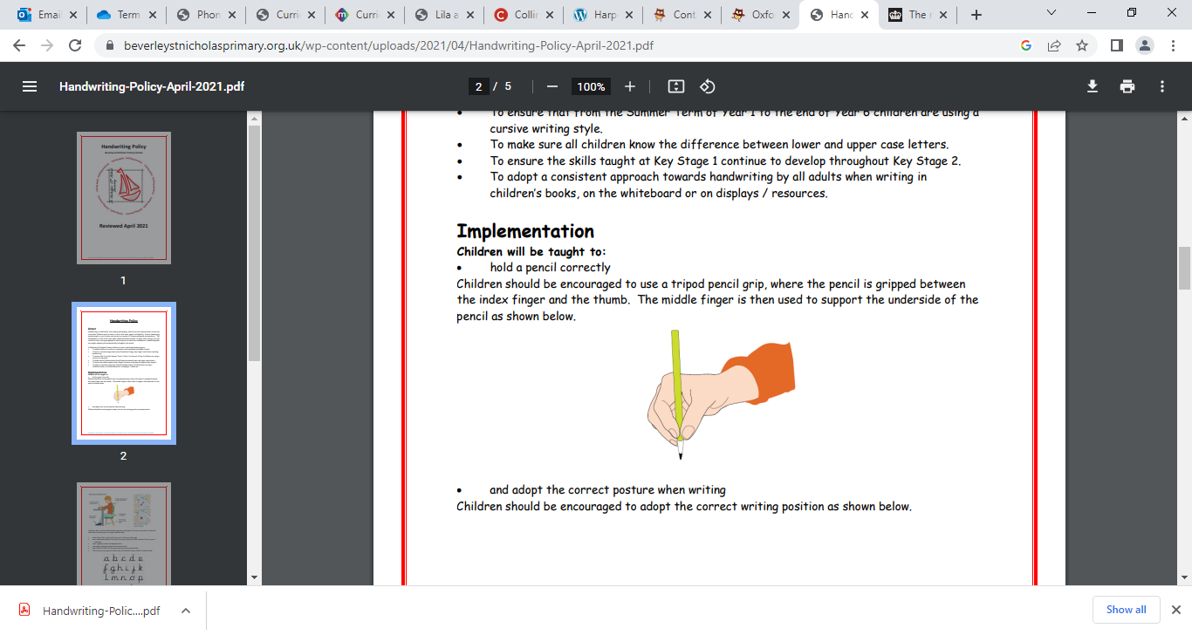

* and adopt the correct posture when writing Children should be encouraged to adopt the correct writing position as shown below.

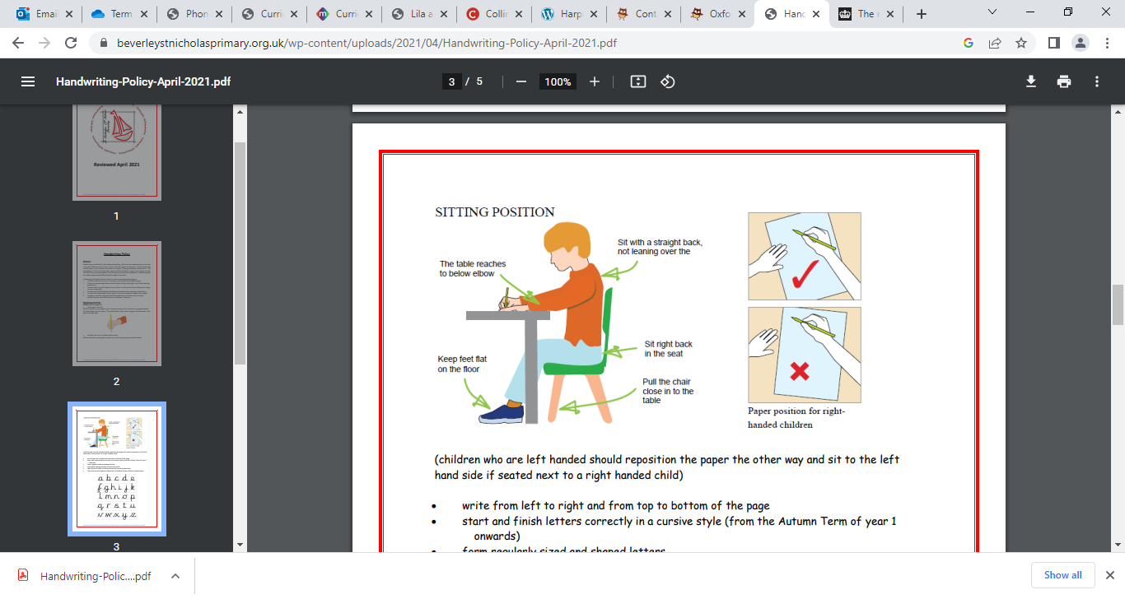

(children who are left handed should reposition the paper the other way and sit to the left hand side if seated next to a right handed child)

• write from left to right and from top to bottom of the page

• start and finish letters correctly in a cursive style (from the Autumn Term of year 1 onwards)

• form regularly sized and shaped letters

• use regular spacing between letters and words

• take a pride in their written work and the overall presentation.

• The cursive script agreed at Beverley St Nicholas Primary School is shown below.

**Handwriting Objectives from the National Curriculum**

**Early Years Foundation Stage**

* Hold a pencil effectively to form recognisable letters, most of which are correctly formed.
* The children’s pencil grip is assessed when they enter year R.
* The children are taught how to use ascenders, descenders and flicks.

**Key Stage 1**

**Year 1**

Children are taught to:

* sit correctly at a table, holding a pencil comfortably and correctly
* begin to form lower-case letters in the correct direction, starting and finishing in the right place
* form capital letters
* form digits 0-9

understand which letters belong to which handwriting ‘families’ (i.e. letters that are formed in similar ways) and to practice these.

**Year 2**

Children are taught to:

* form lower-case letters of the correct size relative to one another
* start using some of the diagonal and horizontal strokes needed to join letters and understand which letters, when adjacent to one another, are best left unjoined
* write capital letters and digits of the correct size, orientation and relationship to one another and to lower case letters
* use spacing between words that reflects the size of the letters.

**Key stage 2:**

**Years 3 and 4**

Children are taught to:

* use the diagonal and horizontal strokes that are needed to join letters and understand which letters, when adjacent to one another, are best left unjoined
* increase the legibility, consistency and quality of their handwriting [for example, by ensuring that the downstrokes of letters are parallel and equidistant; that lines of writing are spaced sufficiently so that the ascenders and descenders of letters do not touch].

**Year 5 and 6**

Children are taught to:

* write legibly, fluently and with increasing speed by choosing which shape of a letter to use when given choices and deciding whether or not to join specific letters
* choosing the writing implement that is best suited for a task.

**Handwriting Equipment**

Children will use line sizes appropriate to their stage in writing. During handwriting sessions handwriting books with 3 lines will be used. **Children will also practice using the use the same sized lines as their other curricula books so that children skills are transferable and that the same expectation of handwriting in set across all writing.**

Children will be reminded of neat/joined handwriting and presentation in all subjects, they will be encouraged to adopt their own style but bad habits in terms of letter formation will be addressed. Children will be encouraged to join consistently and will be focused on increasing their speed. All children should be handwriting in pen using handwriting pens provided by the school when appropriate by the end of Year 3.

**Presentation guidance**

It is essential that all children should have pride in their work and that it is set out well. Where appropriate:

All work must begin with the date. Within Key Stage 2, in Literacy this must be written in the following way: Tuesday 10th September 2023 (example)

* In Key Stage 2, the date should be written on the top line and underlined (not in the margin). The learning objective should be on the line below, this should be underlined.
* In Key Stage 1 the learning objective with a short date is written and underlined- as appropriate for ability/stage of learning.
* Underlining should be completed with a ruler.
* Children should write from the margin to the edge of the page.
* Children will be encouraged to put a line through a mistake. Where appropriate use a ‘white label’ to cover a pen error.
* Rubbers will be used within reason to correct pencil work.
* Criteria for presentation of work will be discussed prior to commencement of work.
* Pictures should be coloured in pencil crayons or plastic crayons. Felt pens should not be used in exercise books.
* When squared paper is used for Maths 1 digit is written in each box and a line is left between each question.
* In Maths a rubber can be used at the teacher’s discretion.

**Handwriting and special educational needs**

Some children may encounter problems with handwriting because they either have a special educational need (SEND) such as dyspraxia, dyslexia or ADHD. For example:

* A symptom of dyspraxia may result in particularly slow, clumsy and pain staking handwriting. Children with dyspraxia or dyslexia can also find it difficult to vary their handwriting speed, consequently their confidence may suffer.
* Where appropriate pencil and specially designed pens/grips will be introduced.
* Where appropriate specific exercises introduced.

Any teacher who has concerns will seek further advice from our SENCO Mrs Angela Liggins; where appropriate teachers will discuss concerns with the child’s parent or carer to see if there are any underlying factors and to assist in any support the children can be given from home.

**Assessment and Recording**

Handwriting is informally assessed throughout every subject and written work using our agreed marking procedures (see our marking and assessment policies). Neat and good handwriting will be highlighted in green when appropriate. Poor handwriting will be addressed in marking and the child will be spoken to about their overall presentation or given some individual support if required.

At St Augustine of Canterbury, we believe that as teaching and support staff we are modelling good handwriting for example on the whiteboard, displays, within contact books or when we are marking and commenting on the children’s work in their books. This modelled handwriting must be neat, in accordance with our school scheme and appropriate to the child’s level of development and understanding.

**Impact**

Handwriting is a skill which affects written communication across the curriculum. Our aim is that children are able to write with ease, speed and legibility. By year 6 children will use cursive handwriting using flowing movements and patterns. This handwriting should be demonstrated in all writing across the curriculum. Writing should be fluid in style to allow children to apply their energy into the content of their writing as opposed to the formation of the letters themselves.